Distribution:  Administrative Policy and Procedure Manuals | Subject: Financial Assistance
Last Review Date:  July 2019; July 23, 2024 | Revision Date:  April 20, 2026 | Page 1 of 9 Pages
Effective Date:  July 2019 | Approved by:  _____________________________________________________  Executive Council

POLICY

La Rabida Children’s Hospital (Hospital) has a tradition of serving the poor, the needy, and all who require health care services. The hospital alone cannot meet every community need. It can, however, practice effective stewardship of resources to continue providing effective healthcare services. The Hospital will continue to play a leadership role in the community by helping promote community-wide response to patient needs, from government and private organizations.

PURPOSE

The Financial Assistance Program (FAP) emphasizes services for those without the ability to pay for necessary medical services. Financial Assistance shall be budgeted each fiscal year for the sole purpose of writing off part or the entire La Rabida Children’s Hospital bill for those unable to pay. Processing the request for Financial Assistance shall be in accordance with the determination of Eligibility, Program Administration, and Income Guidelines. The La Rabida Children’s Hospital “Financial Assistance Application” form shall be utilized to collect financial information from the patient (Appendix B).

IDENTIFICATION -- SPECIAL INSTRUCTION

- Any hospital employee may suggest a patient apply for Financial Assistance by contacting the Financial Counselor or the Patient Financial Services Department.

- Information regarding Financial Assistance, including the Sliding Fee Schedule Discount program is located under larabida.org/Financial-Assistance on La Rabida Children’s Hospital website. Signage is posted in both hospital Admitting and Outpatient departments.

- Patient Financial Services will evaluate all referrals to determine financial need.

- Patients who have sufficient third party coverage or qualify for Public Aid Funds are not eligible for Financial Assistance.

- All candidates for Financial Assistance are to complete a Financial Assistance Application form and verification of income, which may include tax forms, paycheck stubs or letters from employers.

- Completed applications for Financial Assistance are referred to the Financial Counselor.

PROCEDURE:
In accordance with its Financial Assistance Program, La Rabida Children’s Hospital will provide uncompensated or discounted care to patients who are determined to be unable to pay for services. This policy shall be applied in accordance with established procedures and no patient shall be denied Financial Assistance based upon race, creed, color, sex, national origin, or any other prejudgment.

- Eligibility

Patient’s eligibility will be based upon the following information:

- All patient accounts over $100 are eligible for Financial Assistance. The aggregate total of all accounts due from a single patient or family may equal $100 for purposes of consideration. An application must be filled out by the guarantor.

- The Application Period, for which the Hospital will accept and process an individual’s FAP application begins on the date of care is provided and ends on the later of the 240th day after the date the first post-discharge billing statement is provided for the care or
- thirty (30) days after the responsible debtors receives a written notice from the Hospital indicating that financial assistance is available for eligible individuals and
- that as a result of the responsible debtor(s) failure to pay, the Hospital will initiate debt collection actions no earlier than 30 days from the date of the written notification.

- The application includes:
- Income from all sources for individuals responsible for this obligation, listing gross income for the most recent three month period (income from seasonal employment will be based upon the previous twelve (12) month average.
- Resources from savings and checking accounts, certificates of deposit, stocks, home equity and bonds shall be noted on the application.
- A copy of the most recent federal income tax return is required.
- The number of exemptions on the applicant’s most recently filed federal income tax return will serve as the primary source of family size determination.

- All third party resources and in-hospital financial aid programs, including public assistance available through state Medicaid programs must be requested and exhausted before Financial Assistance may be requested.

- Deductibles and co-insurance amounts are eligible for Financial Assistance benefits if financial circumstances warrant.

- Eligibility will be determined by comparing applicant’s income to the Income Eligibility Guidelines found in section II (H), Income Eligibility Guidelines.

- Patient eligibility will be based solely on the information provided directly by the individuals responsible for the obligation. The hospital will not obtain information from other sources to determine eligibility.

- Patients whose primary residence is outside Illinois or Indiana are not eligible for Financial Assistance.

- Program Administration

La Rabida Children’s Hospital’s Financial Assistance Program will be administered according to the following guidelines:
- The application information, along with a copy of the most recent federal income tax return will be reviewed and verified by Patient Financial Service personnel.

- After reviewing income and assets, Patient Financial Service will determine if the patient qualifies for Financial Assistance benefits based upon Income Eligibility Guidelines - section II(H).

- Family income is defined based on definitions used by the U.S. Bureau of the Census and includes earnings, unemployment compensation, workers’ compensation, Social Security, Supplemental Security Income, public assistance payments, veterans’ payments, survivor benefits, pension or retirement income, interest, dividends, rents, royalties, income from estates, trusts, educational assistance, alimony, child support, assistance from outside the household, and other miscellaneous sources. Non-cash benefits (such as food and housing subsidies provided through state assistance programs) are not considered income.

- Requests for Financial Assistance in excess of $5,000 must be approved by the Chief Financial Officer.

- If the patient qualifies for 100 percent discounted care, the patient shall be notified in writing by Patient Financial Services. The written communication will communicate the level of financial assistance the applicant is eligible to receive and the basis for this determination.

If the patient qualifies for a reduction in liability (less than 100% of the amount due), the patient will be notified by Patient Financial Services to establish payment arrangements for the amount due.

- Falsification of information on the application or refusal to cooperate will result in the denial of Financial Assistance.

- Applicants will not be denied Financial Assistance based on race, color, religion, sex, age, national origin or marital status.

- La Rabida Children’s Hospital reserves the right to change benefit determination if financial circumstances have changed. Income Eligibility Guidelines

- Financial Assistance does not apply to insurance companies and other third party payers.

- When a determination of eligibility for Financial Assistance has been made, all accounts of patients within the same family shall be handled in the same manner for care provided for six months for following the date of such determination, without the need for completing a new application. Discounts will be applied to all open self-pay balances. A new application will be required for care provided more than six months after the initial (or other prior) determination or if indications are received that the financial status of the patient or family has significantly changed from the initial evaluation period.
- Financial Assistance Provision:

Families who have income at or below 250% of federal guidelines for poverty will qualify for 100% financial assistance for the medical bills owed to La Rabida Children’s Hospital.

Federal Register, Federal Poverty Guidelines (FPG) - 2026

Families who have income between the range of 201% through 400% of the federal poverty guidelines will qualify for the following payment discounts:

In situations whereby the patient is uninsured and the Family Income is between 380% and 600% of the FPG and Financial Assistance is not otherwise provided under this Policy in the form or free or discounted care, the patient will be responsible for 32.0% of the bill charges as calculated by the hospital’s annual Amounts Generally Billed calculation. (Appendix C)

The maximum payment amount that may be required (for health care services provided by the Hospital) from a patient determined by the Hospital to be eligible under Section III of this policy is 25.0% of the patient’s Family Income and is subject to the six month eligibility period as determined in Section II (J.).

The amount billed to individuals responsible for the outstanding obligations, who qualify for the FAP, will be limited to no more than amounts generally billed to individuals who have public or commercial health insurance covering such care (AGB).

- Non-payment of Financial Obligation:

The first monthly billing statement is generally issued 7 to 10 days after an Inpatient Discharge date or the receipt of Outpatient medical care.

Upon receipt of a Financial Assistance Application, the Hospital or any of its debt collection agencies will NOT engage in any debt collection activities until the Hospital has made reasonable efforts to determine whether the applicant(s) is eligible for assistance for care, under the Hospital’s financial assistance policy (FAP).

At least 30 days prior to the transfer of any past due debt balances to a debt collection agency, the Hospital will:
- provide the responsible debtor(s) with a written notice which indicates that its FAP is available for eligible individuals. The written notice will (1) clearly identify the debt collection actions the Hospital intends to initiate to obtain payment for care and (2) clearly state a deadline date after which the Hospital will initiate its debt collection efforts.
- provide the responsible debtor(s) with a plain language summary of the Financial Assistance Policy (FAP).
- Make a reasonable effort to orally notify the responsible debtor(s) about the hospital’s FAP and about how the individual may obtain assistance with FAP application process.

After the issuance of three monthly billing statements or the later of 125 days from the date the Hospital issued its first post-discharge billing statement, La Rabida Children’s Hospital will transfer the outstanding balance due to a debt collection agency.

If the FAP applicant has multiple episodes of care and the Hospital combines or consolidates the outstanding bills, the Hospital will refrain from transferring the consolidated outstanding balance to a debt collection agency, until at least 125 days after the Hospital has issued its first post-discharge billing statement, for the most recent episode of care in the consolidated debt balance.

The hospital will not report any adverse information about the individuals responsible for the obligation to any consumer credit reporting agencies or credit bureaus.

APPENDIX A
Provider List

Provider Name |  | Subject to Financial Assistance Policy
La Rabida Children’s Hospital |  | Y
Advocate Children’s Hospital |  | N
Central DuPage Hospital |  | N
Cook County Hospital |  | N
Edwards Hospital |  | N
Franciscan Health |  | N
Loyola University Medical Center |  | N
Lurie Children’s Hospital |  | N
Rush University Medical Center |  | N
Sinai Health System |  | N
St. Francis Medical Center |  | N
University of Chicago Medicine |  | N
University of Illinois-Chicago Hospital and Health Sciences |  | N
Medical Express Ambulance Service |  | N

APPENDIX B
Financial Assistance Application

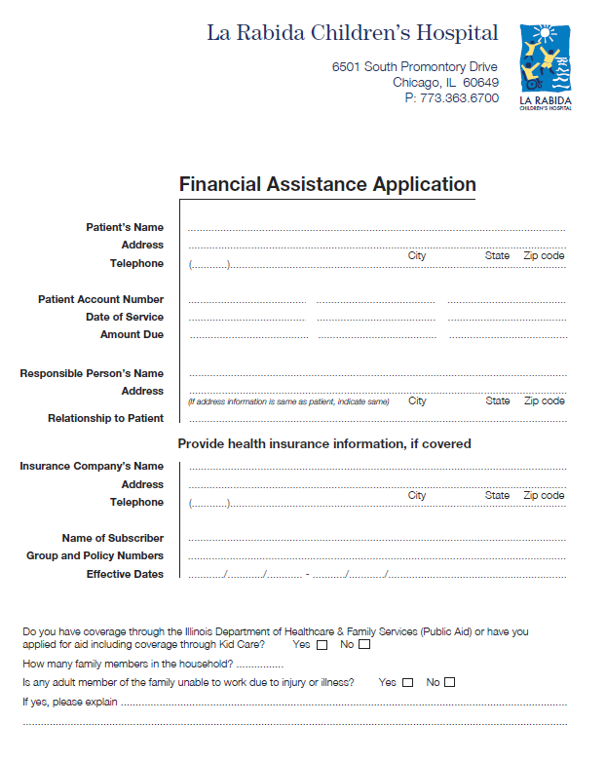
APPENDIX B
Financial Assistance Application – Page 2

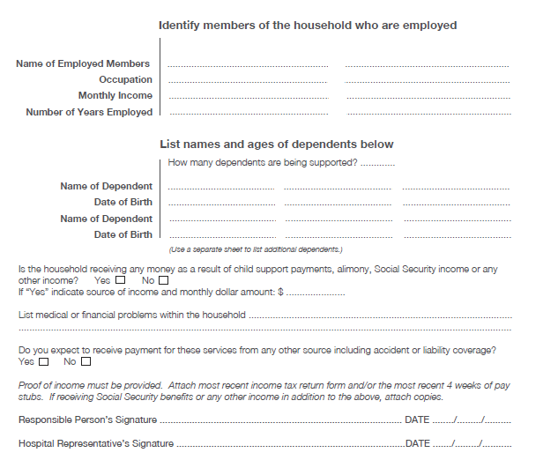
APPENDIX C
Calculation of Amounts Generally Billed

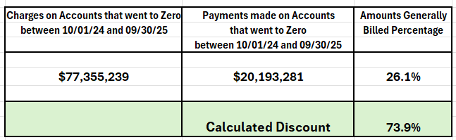

Definition:
Amount Generally Billed:

Charges for emergency or other medically necessary services provided to a patient who is eligible for Financial Assistance shall be limited to no more than amounts generally billed to individuals who have public or commercial health insurance covering such care (“AGB”).

In calculating the AGB, the Hospital has selected the “look-back” method. This means that the AGB is determined based on actual past claims paid to the Hospital by Medicaid Fee for Service claims together with all private health insurers paying claims to the Hospital.

The AGB percentage will be calculated annually by dividing the sum of all claims that have been paid in full during the prior 12- month period by the sum of the gross charges for those claims. This resulting percentage is then applied to an individual’s gross charges to reduce the bill.

A revised percentage will be calculated and applied by the 120th day after the first day of the start of the calendar year used to determine the calculations. The AGB percentage is listed in Appendix C.

